Collingwood School Art Department

Personal Histories and Mythologies – An Artist in Residence Project

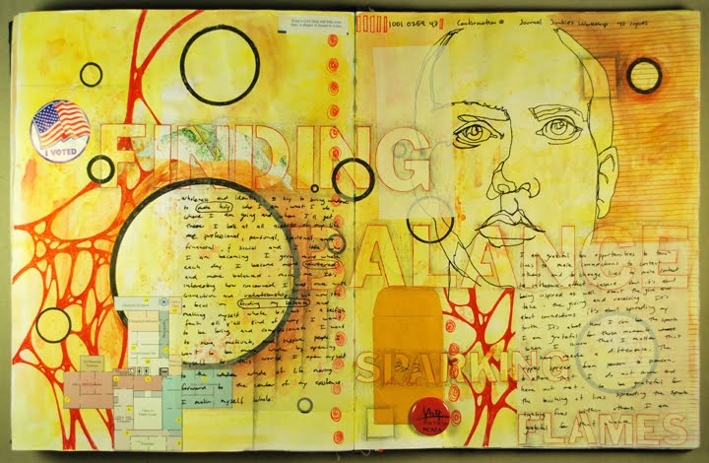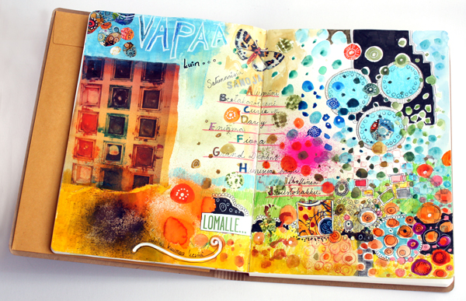
This project is meant to be an exploration of who you are as well as the STORIES that you tell yourself. In this project you will be exploring significant people and events in your life as you introduce or reintroduce yourself to the textile techniques of felting, fabric dyeing, and “drawing with thread” (embroidery and sewing machine). For this project, you will continue to think about your past and the stories you have build about yourself through a reflection on your personal journey to this point in your life. Think about the things that are important to you, and examine your strengths and areas for growth. Identify your core values and how they relate to your personality. Where did these concerns come from? Who has influenced them? Pain along with joy is a part of all of our lives. As you explore your identity and how it relates to your experiences, learn to lean into the pain and celebrate the joys. Confront the disquieting parts and embrace the pleasant memories. Think of this project as telling a little story of an aspect or a few aspects of your life – whether based on fact OR your imagination. THIS PROJECT IS ALL ABOUT YOU

PROJECT CRITERIA
For this project you will need to include the following:
- Choose a main surface to work with (either paper, drawing board, or canvas/cloth) that will be no larger or smaller than 12”x12”
- Work with the ideas/words/phrases from your prompted blog reflections (“I AM,” “PIVOTAL PEOPLE,” “ROADS TAKEN and NOT TAKEN,” and “PERSONAL MYTHOLOGIES”). You can take parts of your written reflections and add them randomly, or not so randomly right into your artwork, for example.
- INSPIRATION – You may choose any of the ideas that pop out for you in your written reflections, or your past in general, as inspiration for the imagery you choose to include for this artwork.
- Must use AT LEAST ONE of the textile techniques that Colette Lisoway has introduced us to in the last several weeks. You are of course welcome to explore 2 or all 3 of the techniques in this piece!
- “THREADS” – You must incorporate an exploration of lines and mark-making in this piece. Think about how lines, marks, and/or shapes could repeat in your composition to create pattern/repetition.
- LAYERING – You are strongly encouraged to explore at least some of the following mixed media techniques you have worked with in your regular art class: collage, transfers, paper staining/marbling, AND the use of paint, inks, pencil-crayons, pastels – all of these are welcome to be explored in this piece along with the textile technique(s) that you choose.
- COLLECT – photos of yourself, especially at different points of your life (think about old school ID cards, family photos, etc.), photos of family members, pets and friends. What other memorabilia or mementos (ticket stubs, postcards, letters/emails, old artwork or schoolwork, etc.) from trips, adventures, different stages of your life, etc. could you replicate/copy (ex. photocopy/scan) or include directly into this 12”x12” work of art? How could these things be layered into the “threads” of your piece?
- RESEARCH – search out artists and artworks that use a lot of different textile techniques and layering techniques of mixed media and use PINTEREST to track 10-15 ideas to start. Keep pinning!!
Essentially, this project is meant to allow for RANDOM as well as PLANNED ACTS OF CREATIVE EXPLORATION:
- Perhaps you could begin by choosing even a small aspect of a story from your life and run with it! For example, maybe you have a childhood photograph that could be scanned/photocopied and some words or phrases from your blog reflections that “speak to you” for some reason. Go with that to start and see what happens.
- Perhaps you want to literally tell a little story of something that actually happened to you in your life.
- Perhaps you want to invent a story about yourself – hence, a myth!

There really are many different directions you could take this assignment. Please refer to your Pinterest Board for inspiration AND continue to seek out more ideas through the links we teacher-types will continue to provide.

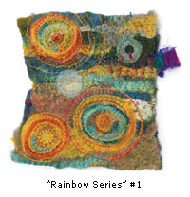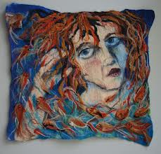
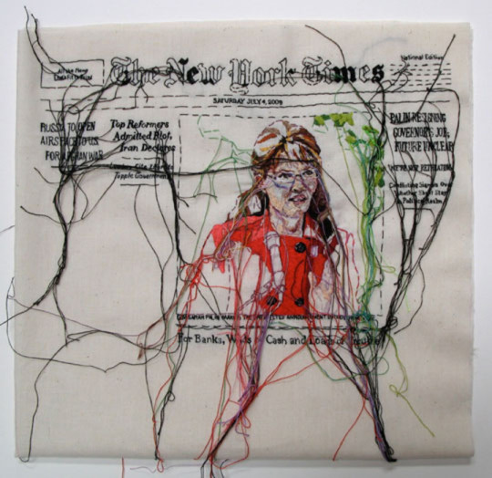
Think about the creative ways that the textile arts of felting, fabric dyeing, and “drawing with thread” have been used by contemporary artists recently. How might you use one or all of them in your 12”x12” work of art telling a story about you?
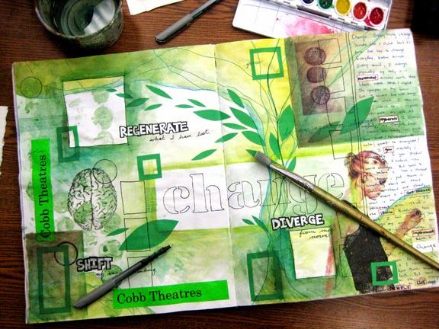

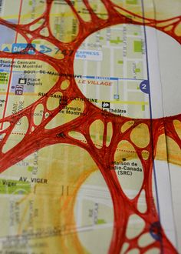
How will you use line, shape, repetition/pattern, colour, found “mementos”, photographs, etc. in your work as part of your story/myth? How will you layer these items? Some of it will likely be planned, while a lot could also be left randomly for chance! Will you work with any other mixed media options such as collage, image transfers, staining, etc.? What other media would you like to explore (ex. drawing, painting, inks, etc.)? Start to write a list if it helps! And get Pinning examples you find on Pinterest!

